2008年广东省汕头市初中毕业生学业考试
英 语
说明：1．全卷共10页，考试用时90分钟(其中听力考试约15分钟)，满分为150分
中听力部分30分)。
2．答题前考生必须将自己的姓名、准考证号按要求填写在密封线左边的空格内，
并将姓名和准考证号写、涂在答题卡指定位置上。
3．试卷分试题和答卷，4个选项以下(含4个选项)的选择题答案在答题卡上作答
超过4个选项的选择题和非选择题的答案在答卷上作答，写在试题上的答案
无效
4．使用答题卡作答，必须用规定的铅笔将答题卡上对应的小题所选的选项涂黑。
5．非选择题须用黑色或蓝色字迹的钢笔、圆珠笔按各题要求答在答卷上，不能用铅笔和红笔。
6．考试结束时，将试题、答卷和答题卡一并交回。
第一卷 语言知识与技能 (共100分)
一、听力理解(本大题分为A、B、C、D四部分，共25小题，30分)
A、听句子(本题有5小题，每小题1分，共5分)
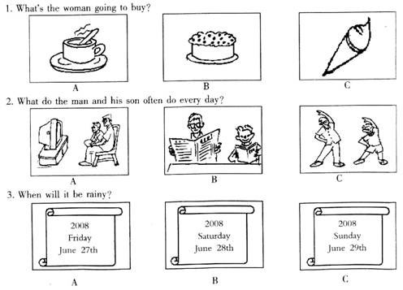
根据所听句子的内容和所提的问题，选择符合题意的图画回答问题，并将最佳选项的字母编号填写在答卷相应题目的答题位置上。若用答题卡答题，则将答题卡上对应题目所选选项涂黑。每小题听一遍。
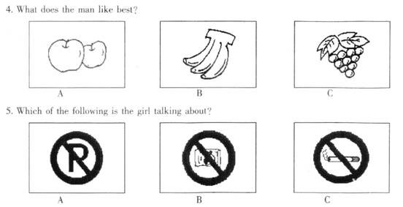
B、听对话(本题有10小题，每小题1分，共l0分)
回答每段对话后面的问题，在各题所给的三个选项中选出一个最佳答案。并将其字母编号填写在答卷相应题目的答题位置上。若用答题卡答题，则将答题卡上对应题目所选的选项涂黑。每段对话听两遍。
听第一段对话，回答第6小题。
6．At what time do you think the conversation took place?
A． At 10 o’clock am． B At 5 o’clock pm． C．At 11 o’clock at night．
听第二段对话，回答第7小题。
7．Why does the man say“Congratulations”to the woman?
A．Because she has passed the driving test．
B．Because she can buy a car for him．
C．Because she can drive a ear for him．
听第三段对话，回答第8小题。
8．What helps the girl a lot with her English?
A．Speaking English． B．Thinking in English． C．Reading English newspapers．
听第四段对话，回答第9小题。
9．What do they both like?
A．The dress．
B．The color“green”
C．The dress and the color“green”．
听第五段对话，回答第10小题。
10．What is the girl’s father？
A．A doctor． B．A shop assistant． C．A postman．
听第六段对话，同答第11—12小题。
11．Where is the man’s company？
A．On Sunshine Road． B．Beside a church． C．Next to a school．
12．How does the girl go to the man’s company?
A．On foot． B．By car． C．By bike．
听第七段对话，回答第13—15小题。
13．What’s wrong with Peter?
A．He’s terribly ill． B．He’s very fat． C．He always feels tired．
14．When does Peter walk to school?
A．When he misses the bus．
B．When he feels tired．
C．When he wants to do some exercise．
15．Which is the girl’s suggestion to Peter?
A．Eating a lot of fast food．
B．Walking to school every day．
C．Going to the gym twice a week to do exercise．
C、听短文(本题有5小题，每小题1分，共5分)
请根据所昕内容，在每小题给出的三个选项中，选出一个能完成句子的最佳答案，并
将其字母编号填写在答卷相应题目的答题位置上。若用答题卡答题，则将答题卡上对应题目所选的选项涂黑。短文听两遍。
16．What was shown to those people at the party?
A．A dog．
B．Dog food．
C．Cameras．
17．Why were the reporters asked to take pictures of the dog?
A．To show how good the dog food was．
B．To show how beautiful the dog was．
C．To show how the dog liked to take pictures．
18．What was the problem when the dog food was put before the dog?
A．The dog didn’t see the food．
B．The dog was afraid of cameras．
C．The dog didn’t like the food at a11．
19．What was the boss like?
A．Hewas handsome．
B．He was fat．
C．He was short．
20．What did the boss of the company do?
A．He was very worried and ran to eat the food himself．
B．He was very angry with the dog and kicked it away．
C．He was very pleased with the reporters and ran to eat the food himselt．

D、听填信息(本题有5小题，每小题2分，共10分)。请将答案写在答卷相应题目的答题
位置上。本题听两遍。
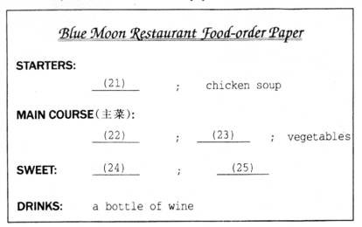
Lily and John are in Blue Moon Restaurant Listen to their conversation with the waitress．Complete the tood they order on the food-order paper．

二、单项填空(本大题有20小题，每小题1分，共20分)
在每小题的四个选项中，选出可以填入空白处的最佳答案，将其字母编号填写在答卷相应题目的答题位置上。若用答题卡答题，则将答题卡上对应题目所选的选项涂黑。
26． youngest leader in China is man called Lu Hao．
A．The；a B．A；the C．A；a D．An；all
27．一John，is Henry your twin brother?
—Oh，yes．He is twenty minutes than me．
A．heavier B．elder C．taller D．older
28．一Is that dog?
—No． is white．
A．his；His B．her；Itis C．he；His D．her；Her
29．The old man began to learn to drive a car at the age of ．
A．sixty B．the sixtieth
C．sixty years old D．sixties
30．I hear that he will be back two weeks’time．
A．at B．in C．after D．for
31．一I’m afraid I can’t go to the party tomorrow
一 you told me you would．What’s happened?
A．And B．So C．Or D．But
32．It takes more time to go there by ship than by bus．It’s by train of the three．
A．faster B．the fastest C．fast D．much fast
33． mothers both work in the same hospital．
A．Tim and Peter’s B Tim’s and Peter C．Tim’s and Peter’s D．Tim and Peter
34．一 do you send an e－mail to your cousin?
—Sometimes．
A．How long B．How much C．How often D．How soon
35．一Don’t kick balls on the road，boys!
A．We will B．We shall C．We won’t D．We aren’t
36．It’s raining heavily．We have to the sports meet
A．put off B．join in C．hold on D．take part in
37．I don’t think Ken did such a stupid thing， ？
A．do I B．did I C．did he D．does he
38．一Jackson，I haven’t seen you these days．
—I for the coming English test．
A．am preparing B．will prepare C．prepare D．have prepared
39．一 you your dictionary?
—No．So I have to buy a new one today．
A．Did；find B．Have；found
C．Are；finding D．Had；found
40．More than two schools in the citv next year．
A．ale built B．were built
C．have built D．will be built
41．Doctor Wang often asks us too much meat．
A．don’t eat B．not eat C．not to eat D．doesn’t eat
42．Both Jim and Kate in Beijing now．They both from America．
A．is；come B．are；come
C．is；comes D．are；comes
43．Tim will call me as soon as he my package．
A．receive B．will receive C．received D．receives
44．—We don’t know ．
—It is said that he was born in Canada．
A．what heis B．when he was born
C．where he comes from D．if he lives here
45．I have bought the camera was advertised on TV．
A．what B．why C．which D．who
三、完形填空(本大题有10小题。每小题2分，共20分)
通读下面短文，掌握其大意，然后在各小题所给的四个选项中，选出一个最佳答案。将其字母编号填写在答卷相应题目的答题位置上。若用答题卡答题，则将答题卡上对应是目所选的选项涂黑。
Do you often think of your parents? You may say，“Of course，I 46 ．I buy a present for my mother on Mother’s Day and on Father’s Day I give my father 47 ，too．”But what ahout the other days of the year?
I have a friend whose parents live in another city．One day 1 went to see her．We had a nice
conversation．Then she wanted to 48 ．So she dialed(拨号) the number，but then she put
down the phone．After about fifleen 49 ，she dialed the number again“Hi，Mom…”
Later I asked，“ 50 did you dial the number twice?”She smiled，“My parents are old and 51 ．They call’t get close to the telephone quickly．I always do so when I call them．I just want to give them 52 time to answer the call．”
My friend is a good girl．She is 53 thinking about her parents．You also want to be a
54 child，right? Please always remember to 55 your parents in every situation，not just on some important days．
46．A．will B．do C．won’t D．don’t
47．A．a cake B．a kiss C．some money D．a present
48．A．make a call B．pay a visit C．have a rest D．go for a walk
49．A．seconds B．minutes C．hours D．days
50．A．How B．What C．Why D．When
51．A．fast B．slow C．healthy D．careless
52．A．little B．quick C．no D．enough
53．A．always B．never C．seldom D．sometimes
54．A．bad B．clever C．good D．sick
55 A．think of B．look after C．ring up D．1isten to
四、阅读理解(本大题有15小题，每小题2分，共30分)
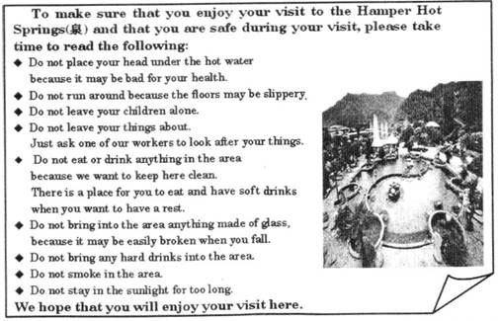
阅读下列短文。并做每篇短文后的题目。从每小题所给的四个选项中，选出能回答所提问题或完成所给句子的最佳答案，将其字母编号填写在答卷相应题目的答题位最上。若用答题卡答题。则将答题卡上对应题目所选的选项涂黑。
A

56．The purpose of this notice is ．
A．to ask people to visit the springs B．to make visitors know the area
C．to tell visitors what not to do D．to tell the visitors to have a rest
57．The notice is written for
A．visitors B．children C．workers D．managers
58．People are not allowed to
A．bring angthing into the area B．have soft drinks in the area
C．look after children in the area D．sit in the sun for long in the area
59． is NOT mentioned in the notice．
A．How long visitors can stay in the area B．What visitors cannot bring to the area
C．Who looks after the visitors’ things D．Whether smoking is allowed in the area
60．The Chinese meaning for“slippery”is ．
A．平坦的 B．湿滑的 C．狭窄的 D．冰凉的
B
Every day，it is easy to see advertisements in English all around us．Look at your own bags and clothes，and at the bags and clothes of your classmates． How many different advertisements can you see which use English words?
Often bags and clothes show the name of the company that made them．This is a popular form．A special picture or symbol called a logo(标识语)is sometimes used．Logos appear on many different products(产品)．They are popular because when you see a logo，it is hard to forget that product or company．
It is common to see advertisements on TV and hear them on the radio．Most advertisements are very short．Sometimes the advertisers use a short sentence which is easy for people to say and remember．Nike，for example，has a simple English sentence which is used all around the world：“Just do it．”Advertisements often use funny situations as well． It is simple to remember it．
All advertisements are designed(设计)to make people buy a product．An advertisement for a soft drink，for example，might show a group of young people who are having fun．The young people are al1 drinking the soft drink．Advertisers are saying to you，“Why don’t you buy this drink and be like these people?You can be young and modern”
You might think that advertisements are not after you，bul the next time you buy a soft drink，ask yourself this question：Why am I buying this particular(特别的)product?
61．From the passage，we know that ．
A．all the advertisements around us are written in English
B．many bags have the name of the company that made them
C．having soft drinks makes a person young and modern
D．advertisements are only after young people
62．A good logo is ．
A．easy to remember B．a useful product
C．difficult to understand D．easy to buy
63．People are most likely to remember an advertisement that is ．
A．in English B．long C．funny D．famous
64．All advertisements are designed to ．
A．sell you something you don’t want
B．make you young and modern
C．make you buy the product
D．show you what you need to buy
65．The best title of this passage may be ．
A．Advertisements for Bags and Clothes
B．Advertisements on TV and Radio
C．Advertisements About Sports
D．Advertisements Around Us
C
请阅读以下左栏人员的相关信息，然后与右栏的广告相匹配。并将最佳选项的字母编号填写在指定位置上。
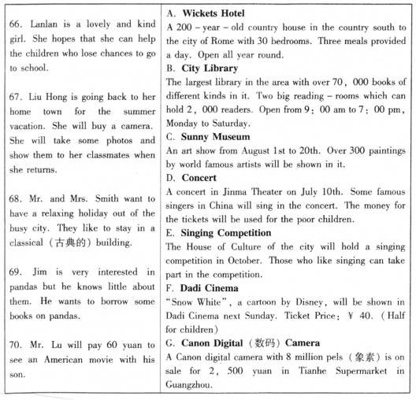
第二卷 综合语言运用能力 (共50分)
五、看图短文填空(本大题有10小题，每小题2分，共20分)
阅读下面短文，并借助上下文和插图补充所缺信息。每个空只能填写一个形式正确、意义相符的单词。请将答案填写在答卷相应题目的答题位置上。
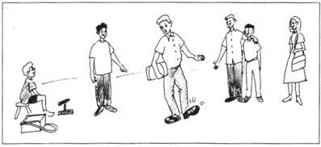

Tom was a poor boy．He made a living by cleaning leather(皮革) 71 for others in the
street．Tom was also a 72 boy．One day，a rich man 73 Miser appeared in front of Tom．
He watched his 74 shoes for a while，and then，looked at Tom．Tom knew this kind of peopl well．They love money but hate to spend it．
Tom said，“Let me 75 your shoes，sir．Only two pence(便土)，sir．
Mr．Miser shook his head and walked away．
Tom thought for a second and then called out，‘‘I’d like to clean it for nothing．”This time
Mr．Miser agreed．And soon one of his shoes was shining brightly．
When the rich man put his other shoe on the stool(凳子)，Tom said he wouldn’t clean it for
Him 76 he was paid tw0 pence for his work．Mr．Miser was very 77 ．He refused to pay
anything and went away．
But to his 78 ，the well－cleaned shoe was so bright that it made the other one look even
dirtier．Mr．Miser looked round．People in the street were 79 at him．
Finallyn the rich man 80 and gave Tom two pence．In a very short time his two shoes shone brightly．
六、读写综合(本大题分为A、B两部分，共30分)
请将答案填写在答卷相应题目的答题位置上。
A．信息归纳(共5小题。每小题2分)
下面是一篇摘自《上海中学生英文报》网站的报道。请仔细阅读该报道，按信息表中
项目要求在答卷上的信息表中填写信息。
Depending on yourself
Growing up is not always easy．When we face difficulties，a spirit of depending on yourself is more useful than crying for help．That’s what Hong Zhanhui’s story of growing from boy to man with family hardship tells us．
Hong was born in 1982 in a poor family in Xihua County(县)，Henan Province．When he was only 11，his father became badly ill and one day he came back with an unwanted baby girl．A year later，Hong’s mother left home．She no longer wanted to live such a poor life and face her sick husband．So everything hard fell onto the young boy’s shoulders：to take care of his father and the sister Chenchen，and to go on to study．
Although his life was hard，Hong didn’t go away from his father and sister．He worked in part
—time jobs to feed his family．He climbed tall trees to get birds’eggs for his sister． He walked two hours at weekends to the market to buy different things to sell around his school．A few years later，he studied at a college．To take care of Chenchen，he worked hard to rent(租)a room near his college for her，and send her to school．
After Hong’s story went public，he became a hero in people’s eyes．But Hong refused offers
from others．He said he felt encouraged by kind offers，but he could depend on his own work．
Through his hard life，he has grown up from boy to man．
From：Shanghai Middle School English Online
Information Card
81． | Hong’s spirit
82． | Hong’s birthplace
83． | Hong’s age when his mother left home
84． | The distance between Hong’s school and the market
85． | The way Hong fed his family
B．书面表达(本题20分】
你看了这篇报道后．感受如何?请结合报道的内容。用英语写一篇80个词左右的日记.
内容包括：1、简要说明洪战辉同学的事迹；2、谈谈你的看法和认识(至少三点)。
日记开头已给出，不计入总词数。请将日记写在答卷相应的位置上。

Saturday June 12th Cloudy
Today I read something about Hong Zhanhui online．

2008年广东省汕头市初中毕业生学业考试
英语试题A参考答案和评分说明
一、听力理解。
A．听句子(本题有5小题，每小题1分，共5分)
1．B 2．C 3．C 4．A 5．C
B．听对话(本题有10小题，每小题1分，共10分)
6．B 7．A 8．C 9．B 10．C 11．C 12．B 13．C 14．A 1 5．C
C．听短文(本题有5小题，每小题1分，共5分)
16． B 17．A 18．C 19．B 20．A
D．听填信息(本题有5小题，每小题2分，共10分)
21．apple juice 22．beef 23．pork 24．fruit salad 25．chocolate cakes
二、单项填空(本大题有20小题，每小题1分，共20分)
26．A 27．D 28． A 29．A 30． B 31． D 32．B 33．C 34． C 35．C
36．A 37．C 38．A 39．B 40．D 41．C 42．B 43．D 44．C 45．C
三、完形填空(本大题有10小题，每小题2分，共20分)
46． B 47．D 48．A 49．A 50． C 51．B 52．D 53．A 54．C 55．A
四、阅读理解(本大题有15小题，每小题2分，共30分)
56．C 57．A 58．D 59．A 60．B 61．B 62．A 63．C 64．C 65．D
66．D 67．G 68．A 69．B 70．F
五、看图短文填空(本大题有10小题，每小题2分，共20分)
71．shoes 72．clever／bright／wise 73．called／named 74．dirty
75．clean／brush 76．unless／until／before 77．angry／unhappy 78．surprise
79．laughin／looking 80．Returned／agreed
六、读写综合(本大题分为A、B两部分，共30分)
A．信息归纳(共5小题，每小题2分)
81．depend(ing)on oneself／yourself／ourselves
82．Xihua County，Henan(Province)
83．12／twelve(years old)／at the age of twelve
84．two hours’walk／two-hour walk
85．work(ing)in part-time jobs/depend(ing) on his own work／on his own work
B．书面表达(本题20分)
Saturday June 12th Cloudy
Today I read something about Hong Zhanhui online．I am deeply moved．Hong was
born in a poor family．His father was badly ill when Hong was 11 and his mother left them．
He had to look after his father and sister．He didn’t accept helps from others and depended
on his own．He was a superman in my eyes．
No one can avoid facing difficulties．But many teenagers are too weak to face troubles．
Learn to be strong and never say“I can’t'’；tomorrow will be another fine day．(82 words)
评分标准：
第一大题D部分
本题的5个小题主要考查考生的听的能力，而不是考查单词拼写。因此，如果考生能听懂所听材料，但在单词拼写上如有个别字母或大小写错误，建议不扣分。
第五大题
考生所填答案与所给答案一致，或意思符合短文内容要求，形式正确给满分：所填答案意思相符但形式有错扣1分；意思不符不给分。其中，71．写成shoe，扣1分；72．写成smart
不给分；73．写成name／call扣1分；75．写成to clean／to brusk／cleaned／brushed扣1分；78．写成surprised／surprlsing／surprises扣1分；79．写成laugh／look／laughed／looked扣1分； 80．写成return／returns／agree／agrees扣1分。
第六大题
A．信息归纳，共5小题，每小题2分。
信息准确，没有语法错误，给满分；信息不完整，每题扣0.5分；信息错误不给分。单词拼写错误，每一个词扣0.5分；大小写和标点符号错误的酌情扣分(其中第82题需要考虑大小写)；84．写成two hours，扣1分。
B．书面表达，1题，共20分。
1．评分原则与方法：
(1)采用总体评分法：考生能否根据写作提示，较好地把阅读文章中与写作相关的内容 进行归纳、提炼、运用来完成书面表达任务。评分时，先确定所属档次，然后以该档次的要求进行微调，最后给分。原文照抄的，只能在第5档中调整；但正确引用原文少数句子且运用得当的，不扣分。
(2)注重内容的完整及语言表达的准确：本题在写作具体内容上给了考生较大的发挥空 间，评分时不考虑观点的正确与否(思想政治观点除外)，只要求考生能准确地表达个人观点，并给出支撑自己观点的理由(不少于三条)。语法、单词拼写和标点符号 错误，每处扣0.5分。
(3)少于或多于规定词数15个的扣l一2分。
(4)对于在完成任务前提下的适当发挥，最多加分不超过2分。
2．内容要点和分数分布：
(1)洪战辉的简要事迹。…………………………………………6分
(2)看法和认识(每条3分) ………………………………………9分
(3)整体把握意思表达以及卷面情况……………………………2分
(4)语法结构、单词拼写…………………………………………3分(扣完本部分分数为止)
3．评分档次和标准：
第一档：17—20分。要求：内容涵盖所有的要点，表达准确，意思连贯，符合逻辑，只
有个别语言错误。
第二档：13—16分。要求：内容涵盖所有的要点，表达清楚，意思连贯，符合逻辑，但
有少数语言错误。
第三档：9—12分。要求：内容涵盖大部分要点，表达较为清楚、连贯，基本符合逻辑，
但有一些语言错误。
第四档：5—8分。要求：内容涵盖部分要点，能写出少量正确句子，但整体表达不太连
贯，且语言错误较多。
第五档：0—4分。只能写出一些单词，不成句子，缺乏逻辑性，错误很多．

注：以上答案及评分标准仅供参考，可按照当地要求做出调整。

声明：本资料由 考试吧（Exam8.com） 收集整理，转载请注明出自 http://www.exam8.com
服务：面向较高学历人群，提供计算机类，外语类，学历类，资格类，会计类，工程类，医学类等七大类考试的全套考试信息服务及考前培训.

